**Step to follow**

**Step 1 -**

* Download GitHub repo [Link](https://github.com/mlpocprojects/mlsecurity_app) and extract the file.

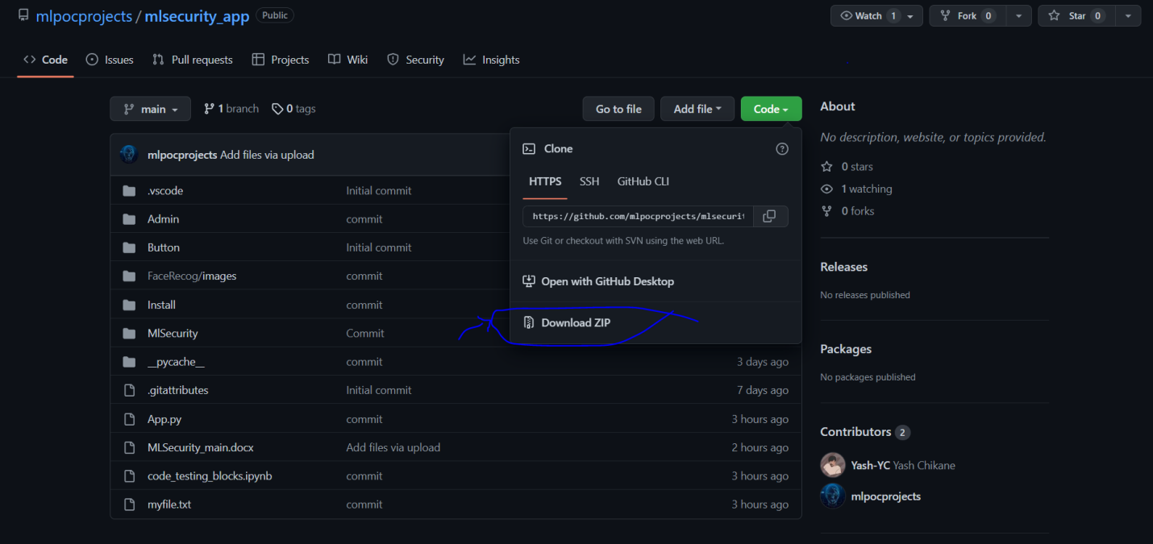

* Open Extracted folder with PyCharm or any other IDE.
* Now go to App.py and run the file.

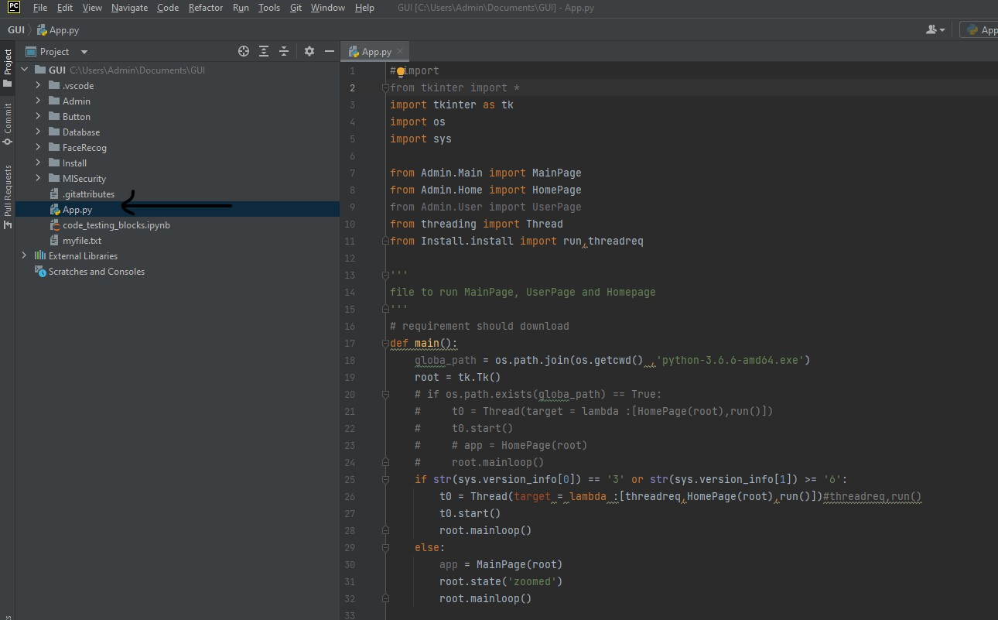

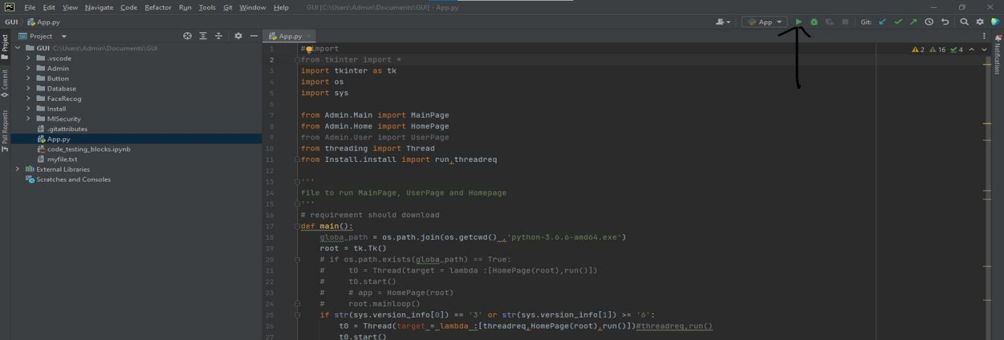

If python version is satisfied image 1 will be displayed or else image 2.

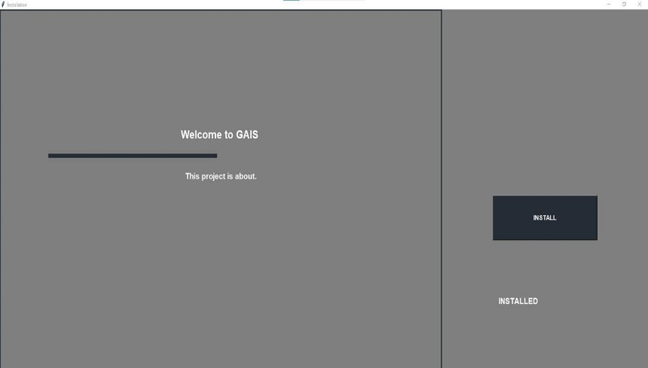 **Image 1**

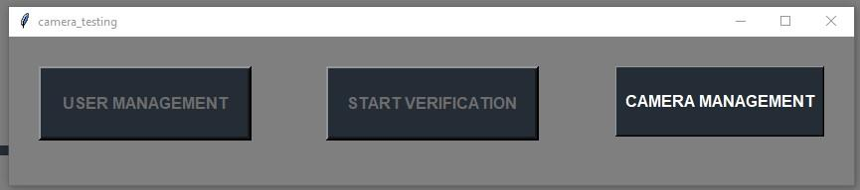

**Image 2**

**Step 2:**

There are Three button as we can see in following image

* **Camera Management**:

It can be used to check you camera which will display following image (After checking your camera other two button will be enabled).

Where you have to check camera by putting Camra Url

* **Test camera**: Is used to test your camera
* **Press camera**: To stop the camera
* **Close camera**: To close the camera management frame.

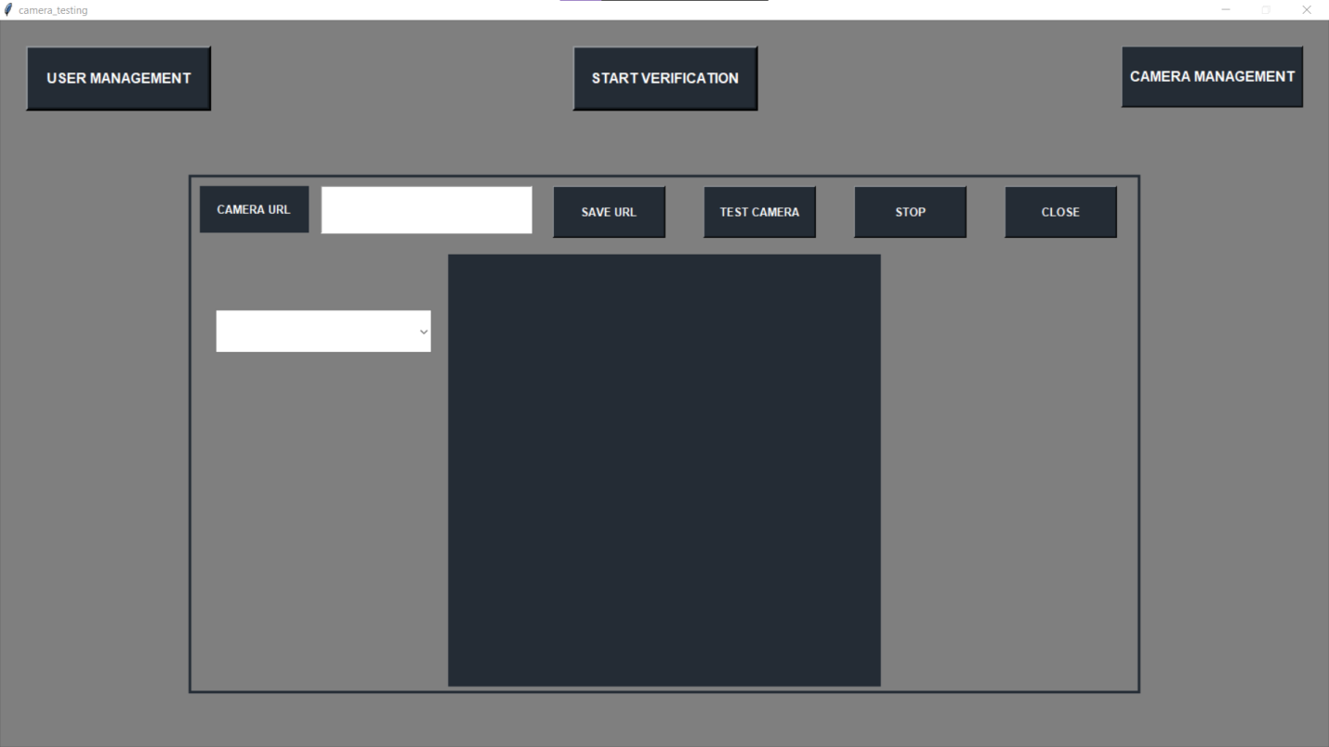

**Step 3:**

From display 2 by clicking **user management**, it will give user following screen

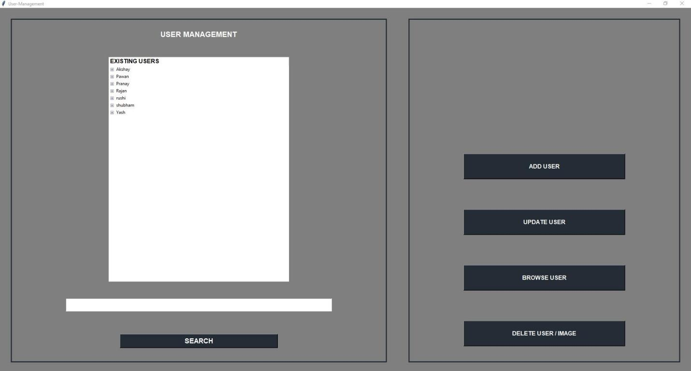

* In **user management** than there is search bar which is used to search specific user among rest of it.

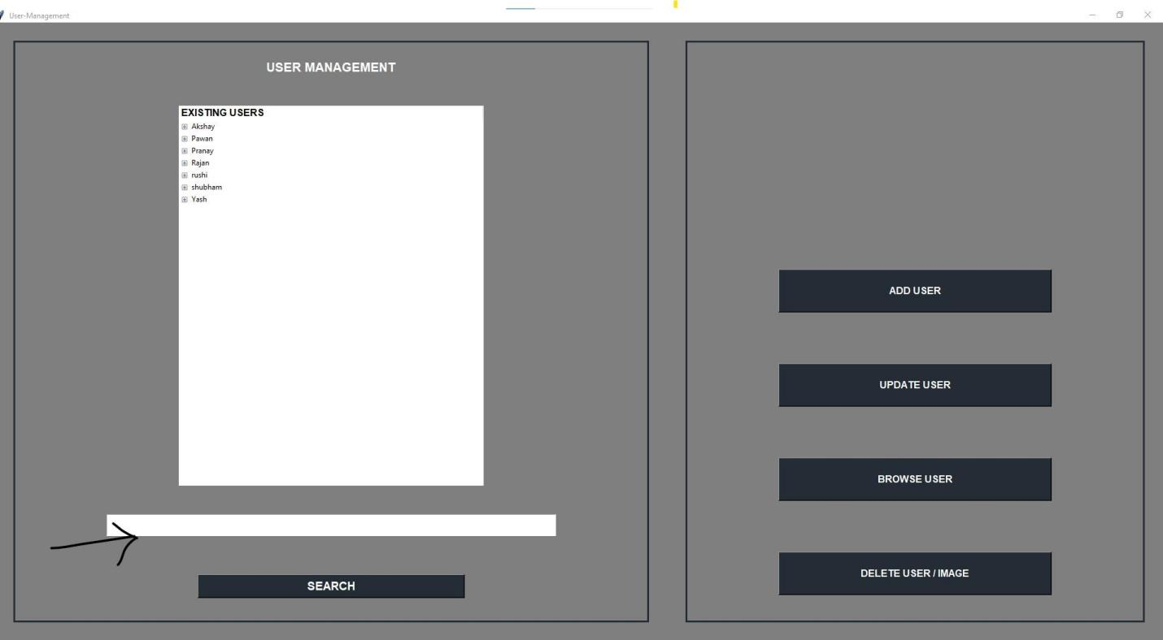

* **Add user button** (which will show entry box and browse button)
* where you can put new user name which you need to add and browse button will used to select image and add to new user

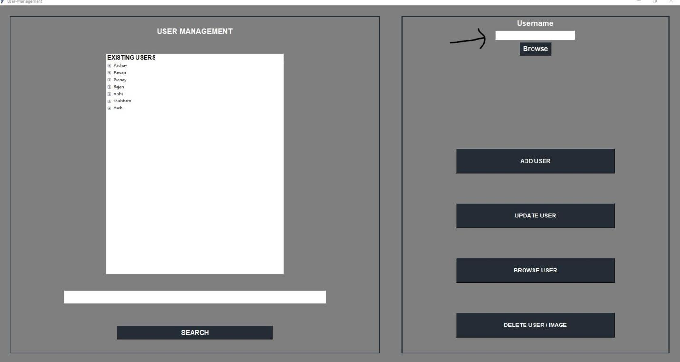

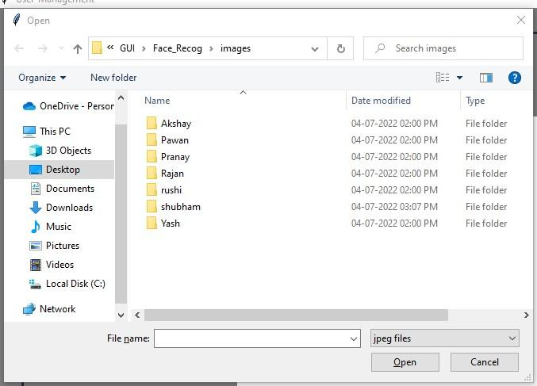

* **Update button** which is used to update user images from directory where user can add images you just need to select user by selecting user from list by pressing it and clicking update button. It will update added images to user.

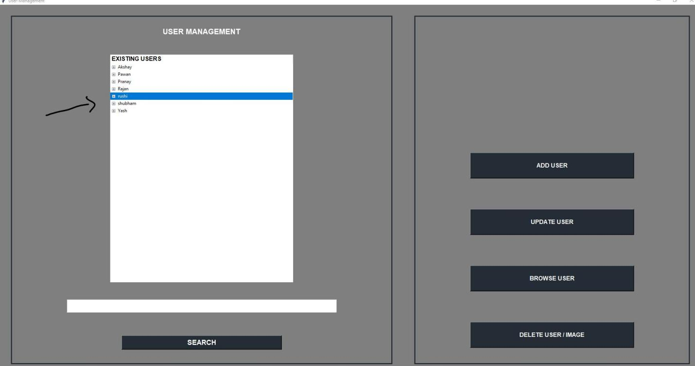

* **browse button** which is used to browse user and see images in it you just have to select user from list and press browse image button to browse.

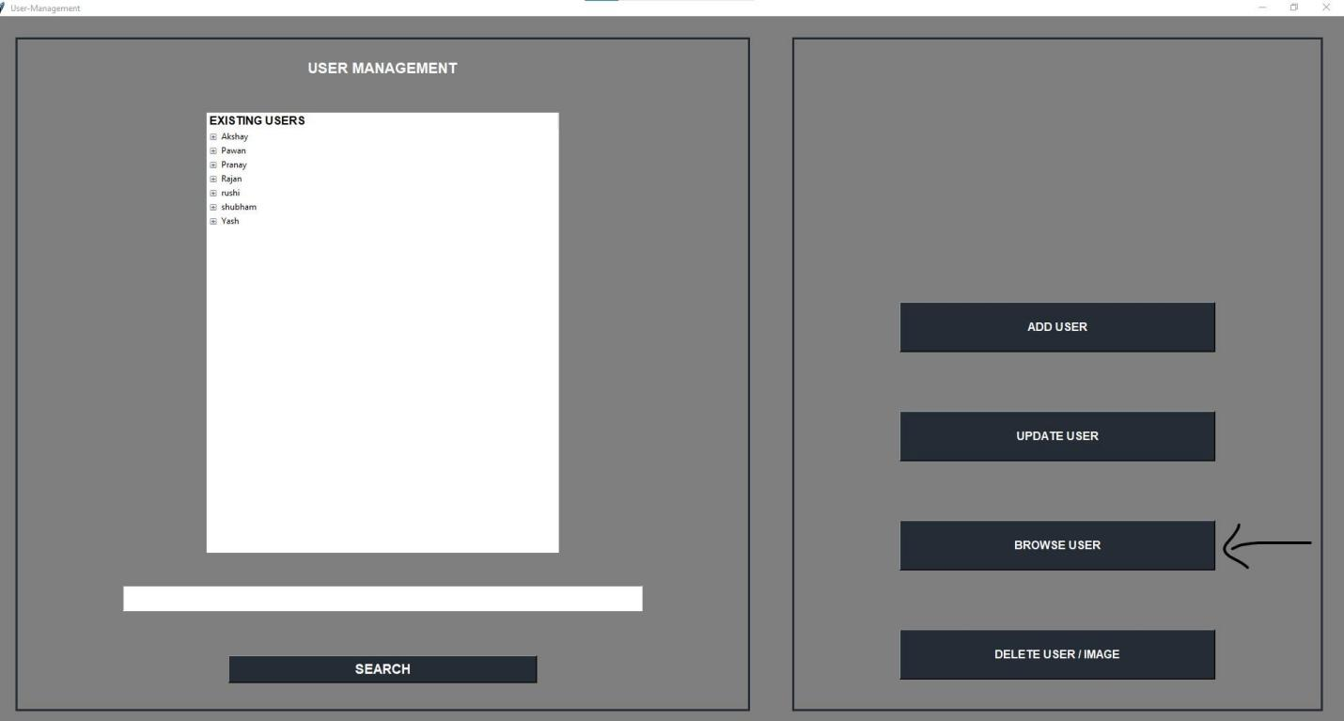



* **Delete button** which is used to delete specific user images or image directory of user you just have to select specific image or user directory,

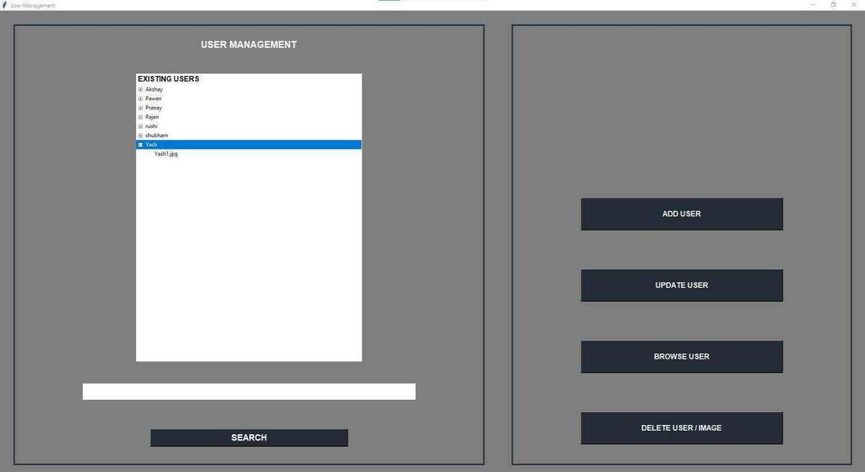

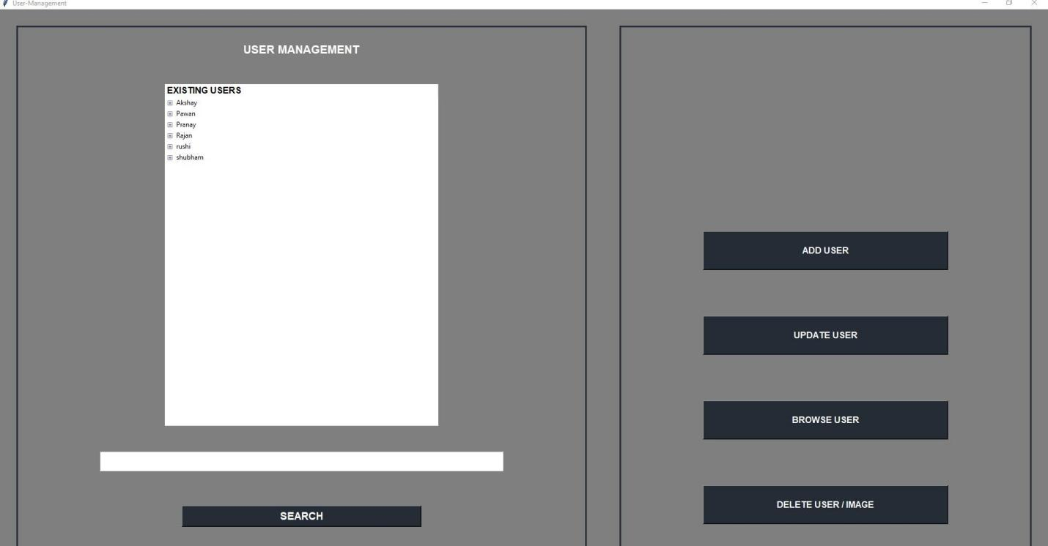

**Step 4:**

After performing user management we need to start face detection model by pressing start detection button.

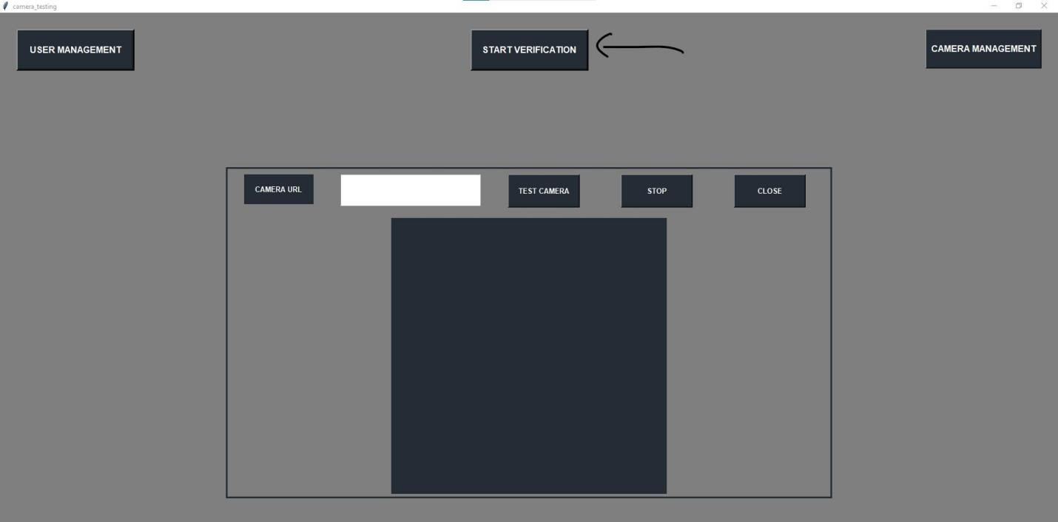

After That it takes some time and automatically opens a link in browser and start face detection.

